**Problema:**

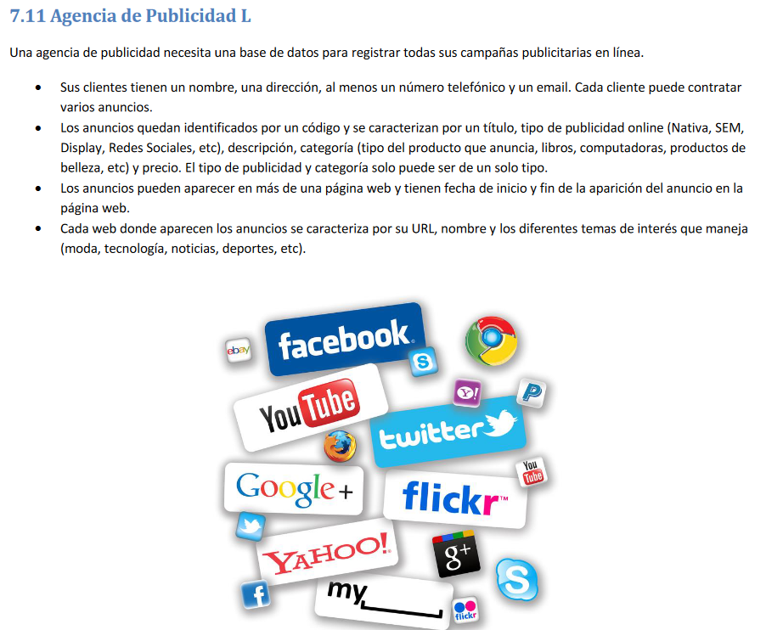

**Modelo conceptual:**

**Modelo lógico:**

**Excel:**

